Task 01

TestJunit.java

import org.junit.Test;
import static org.junit.Assert.assertEquals;

public class TestJunit {
@Test
public void testSubtract() {
int num1 = 10;
int num2 = 5;
int res = num1 - num2;
assertEquals(5 , res);
}
}

TestRunner.java

import org.junit.runner.JUnitCore;
import org.junit.runner.Result;
import org.junit.runner.notification.Failure;

public class TestRunner {
public static void main(String[] args) {
Result resobj = JUnitCore.runClasses(TestJunit.class);
for (Failure fobj : resobj.getFailures()) {
Sout(fobj.toString());
}
sout(resobj.wasSuccessful()); //--> true
}
}

Test 02:

Implement the above code also add one more test case and test runner.. And execute the test suite.

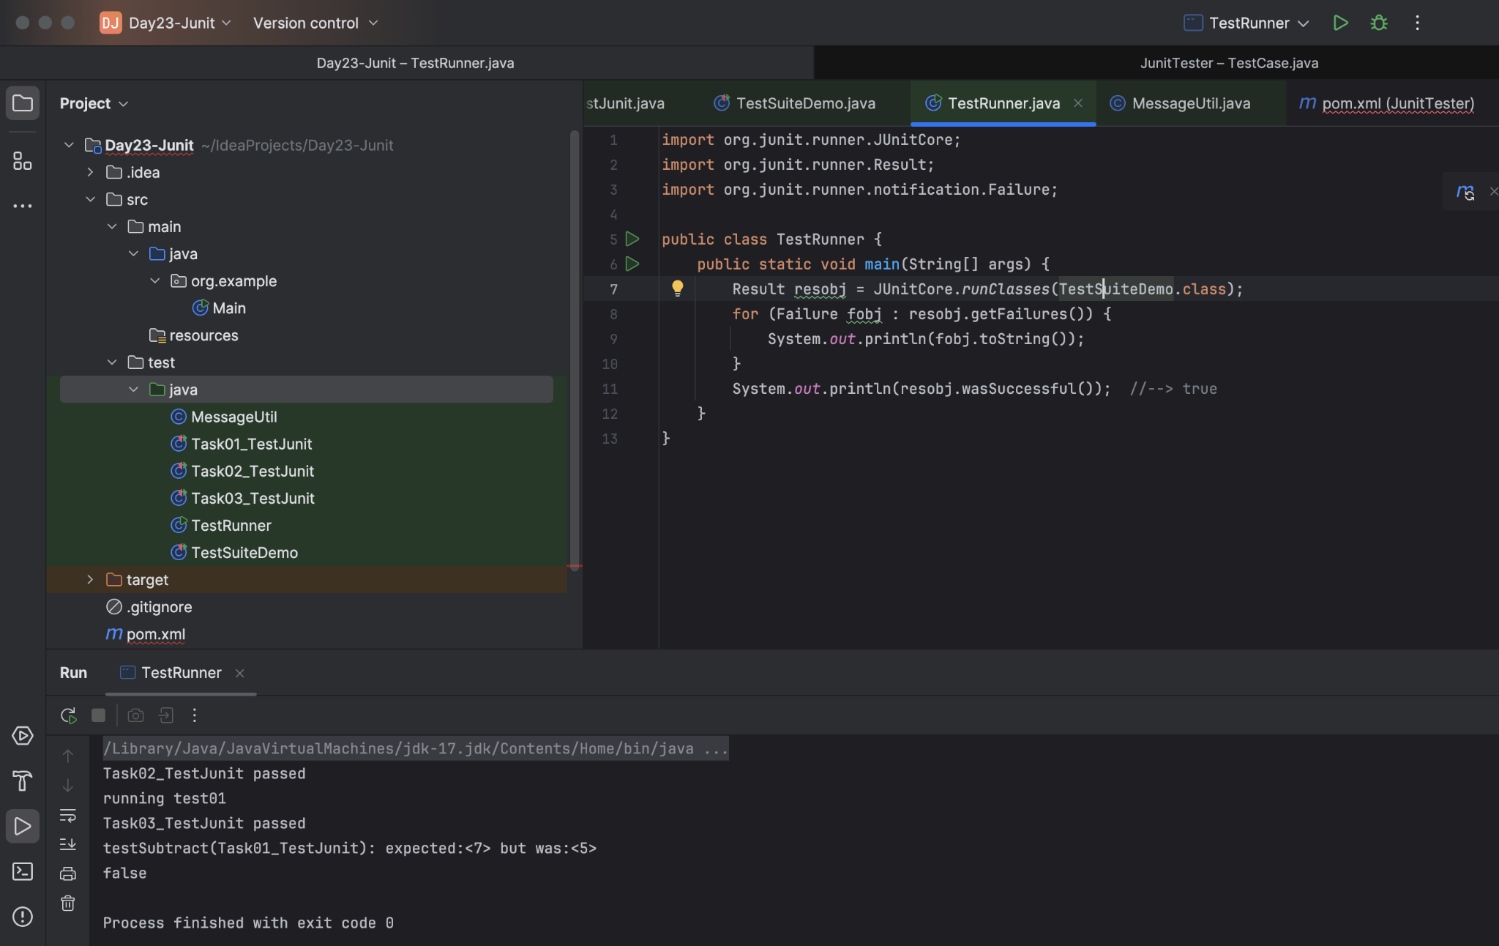

++++++++++++++++++++++++++++++++++++++++++++++++++++++++++++++++++++++++++++++++++++++++++++++++++++++++++++++++++++++++++++++++++++++++++++++++
Home Task:

Task 01:

List down the methods of Assertion class in Junit

assertEquals(expected, actual)
assertNotEquals(unexpected, actual)
assertTrue(condition)
assertFalse(condition)
assertNull(object)
assertNotNull(object)
assertSame(expected, actual)
assertNotSame(unexpected, actual)
assertArrayEquals(expectedArray, actualArray)
assertThrows(expectedType, executable)
assertDoesNotThrow(executable)
assertAll(executables...)

Task 02:

Implement

assertNotSame
assetSame
assertArrayEquals()

Methods in your codes..

Task 03:

Add @Ignore to your one of the test case and check if thet case is ignored or not
Ignored the Task03_TestJunit

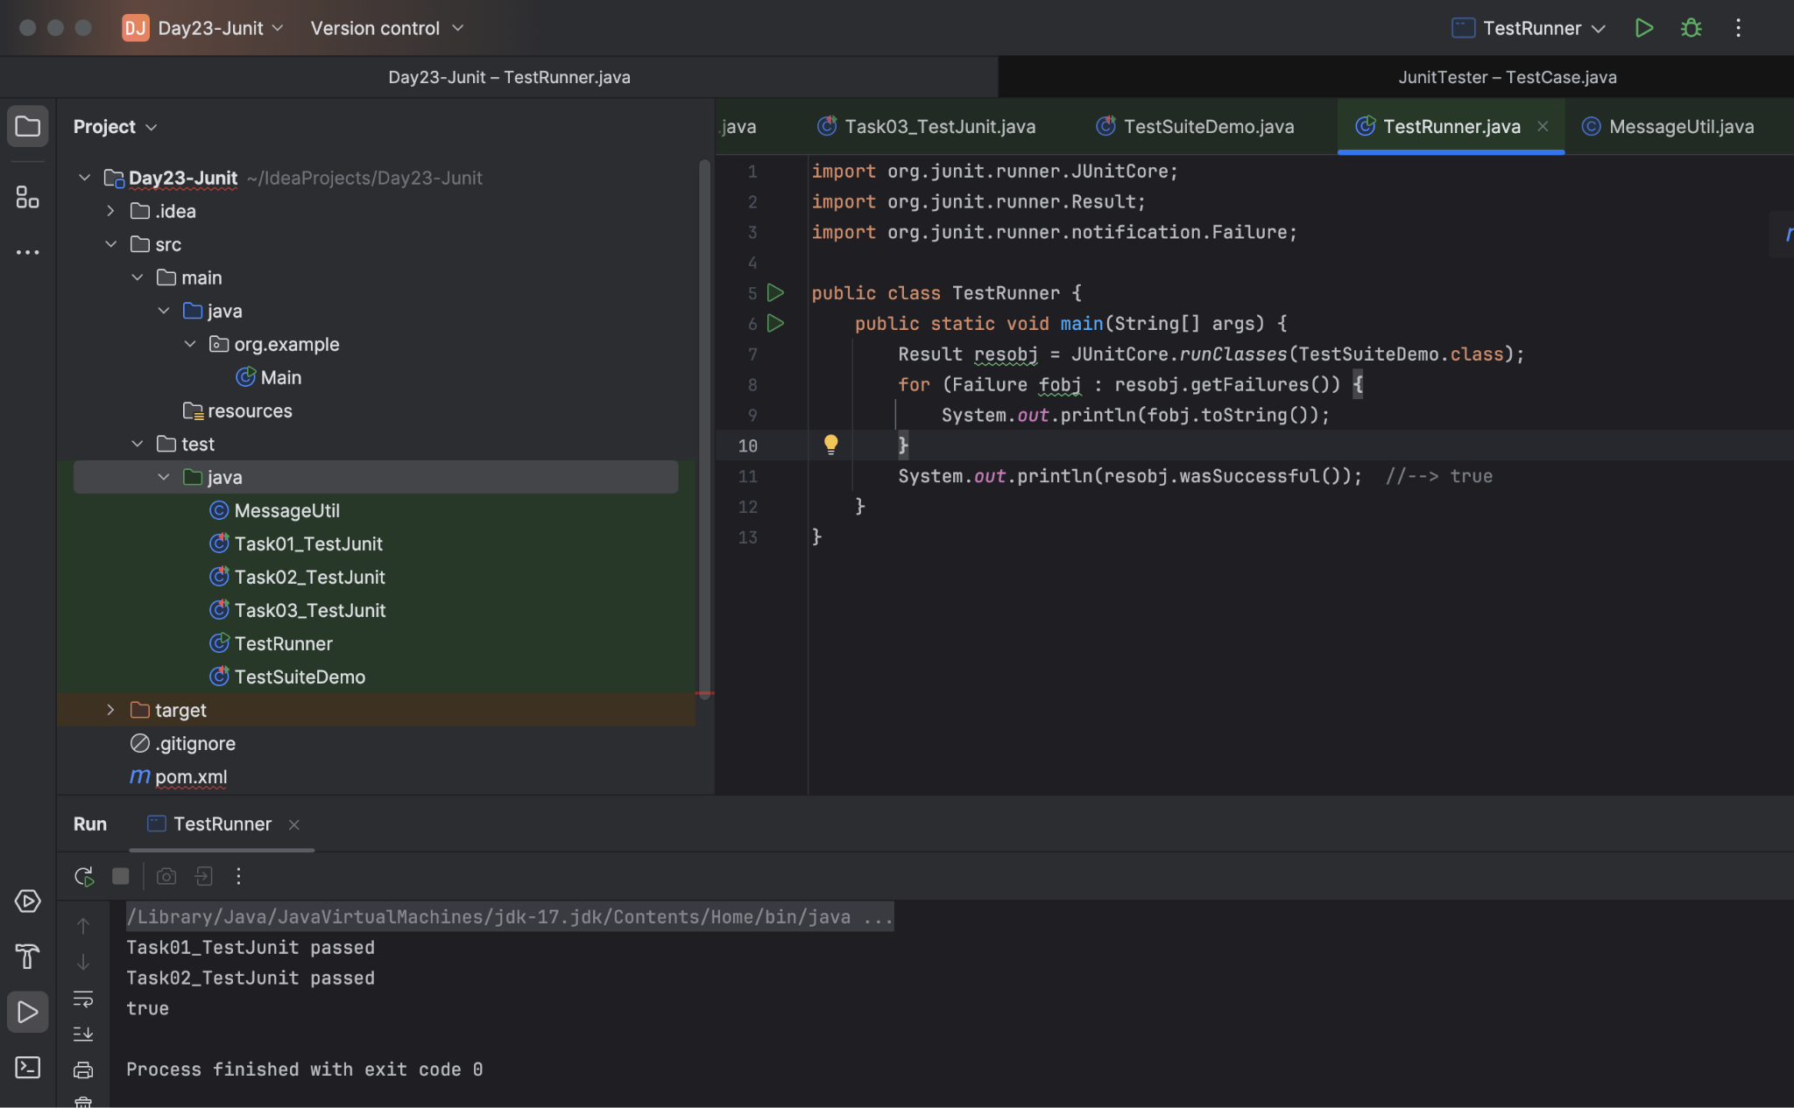

Task 04:

Time Test

In one the tests pass the timeout parameter with value and check if the test case fails if the time is out

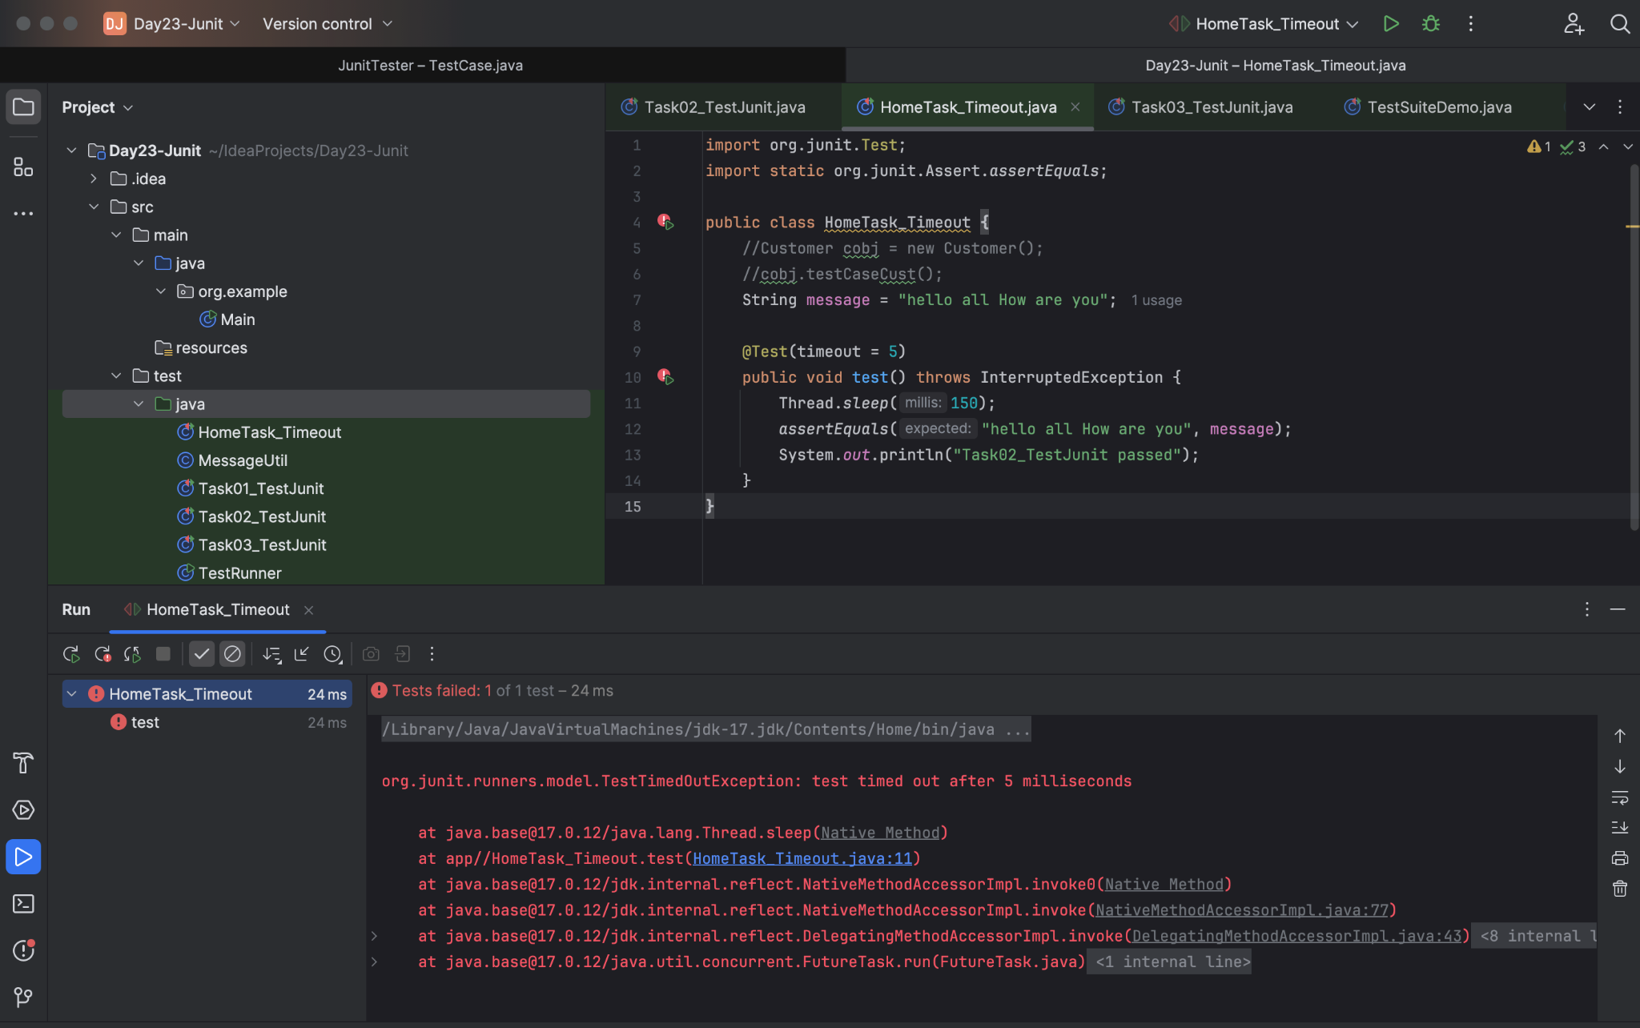

Task 05:

Exception test

In one of your tests check for arithmetic exceptions and see if it works..

@Test(expected = ArithmeticException.class)

